Food Ordering Behavior and Consumer Trends

Food Ordering Behaviour and Consumer Trends Project Report
ABSTRACT :
Food Ordering Behaviour and Consumer Trends is a Business Intelligence project developed using Tableau to analyze customer ordering patterns and consumer preferences. The project uses a food ordering dataset containing 50,000 records and 19 columns. The dataset was connected to Tableau, where data was explored and visualized using interactive charts, dashboards, and stories. The analysis focuses on customer demographics, cuisine preferences, restaurant segments, meal types, revenue contribution, customer ratings, city-wise order distribution, and delivery performance. The completed dashboard provides meaningful insights that can help food delivery businesses understand customer behavior, improve operational efficiency, and support data-driven decision-making.

INTRODUCTION
Business Intelligence plays an important role in helping organizations transform raw data into meaningful insights. In this project, Tableau was used to analyze the Food Ordering Behaviour dataset and understand customer ordering patterns, cuisine preferences, restaurant choices, revenue contribution, customer ratings, and delivery performance. Interactive visualizations, dashboards, and stories were created to present the analysis in a clear and user-friendly manner. The project demonstrates how data visualization can support better decision-making and improve business performance in the food delivery industry.

PROBLEM STATEMENT
The food delivery industry generates a large volume of customer order data every day. Analyzing this data manually is difficult and time-consuming. The objective of this project is to use Tableau to analyze customer ordering behaviour, identify food preferences, evaluate revenue contribution, study customer ratings, and understand delivery performance. The insights obtained from this analysis can help food delivery businesses improve customer satisfaction, optimize operations, and make informed business decisions.
OBJECTIVES
The main objectives of this project are:
- To analyze customer food ordering behaviour using Tableau.
- To identify customer preferences across different cuisines and cities.
- To study order distribution based on age groups and restaurant segments.
- To compare orders across different company types and meal types.
- To analyze customer ratings for different meal categories.
- To evaluate the revenue contribution of each meal type.
- To analyze the distribution of delivery time across orders.
- To develop an interactive dashboard and Tableau Story for effective data visualization and business insights.

SCOPE OF THE PROJECT
This project focuses on analyzing customer food ordering behaviour using Tableau by transforming raw data into meaningful visualizations and interactive dashboards. The analysis covers customer preferences across different cuisines, cities, age groups, restaurant segments, company types, and meal types. It also evaluates important business metrics such as order volume, revenue contribution, customer ratings, and delivery time. Interactive filters and dashboards allow users to explore the data dynamically and identify trends with ease. The insights generated through this project can help food delivery businesses improve customer satisfaction, optimize operational efficiency, understand consumer behaviour, and support data-driven decision-making. The techniques used in this project can also be extended to larger datasets and real-time business environments for advanced analytics and reporting.
DATASET COLLECTION
The Food Ordering Behaviour dataset was provided in CSV format and imported into Tableau using the Text File connection. The dataset contains 50,000 records and 19 columns, representing various aspects of customer food ordering behaviour. It includes information such as Order ID, Customer Age, City, Cuisine Type, Restaurant Segment, Meal Type, Order Value, Delivery Fee, Customer Rating, and Time Taken to Order. After importing, the dataset was verified to ensure that all records were loaded successfully and were ready for further analysis.

SOFTWARE, TOOLS AND TECHNOLOGIES USED
The following software and tools were used to develop this project:
- Tableau 2026.2 – Used for data connection, data visualization, dashboard creation, and story development.
- CSV Dataset – Used as the data source containing food ordering behaviour records.
- Microsoft Excel – Used to review and verify the dataset before importing it into Tableau.
- Windows Operating System – Used as the development environment for the project.
- Google Drive – Used for storing and sharing the project files and demonstration video.
This combination of tools helped in efficiently analyzing the dataset and creating interactive dashboards that provide meaningful business insights.

CONNECTING THE DATASET TO TABLEAU
The Food Ordering Behaviour dataset was imported into Tableau using the Text File connector. After selecting the CSV file, Tableau automatically loaded the dataset into the Data Source page, where all fields and records were displayed. The data types of each field were verified to ensure accuracy before starting the analysis. A total of 50,000 records and 19 columns were successfully imported without any data loss. Once the dataset was validated, it was ready for creating visualizations, dashboards, and stories for further analysis.
DATA REVIEW AND EXPLORATION
After importing the dataset into Tableau, the data was reviewed to understand its structure and ensure its quality. Tableau automatically classified the fields into Dimensions and Measures based on their data types. Fields such as City, Cuisine, Meal Type, Restaurant Segment, Company Type, and Age Group were identified as dimensions, while Order Value, Delivery Fee, Rating Given, and Time Taken To Order were identified as measures. The dataset was explored to understand the relationships between different variables before creating visualizations. This initial exploration helped in selecting appropriate charts and performing meaningful analysis.

DATA CLEANING AND PREPARATION
Before creating the visualizations, the dataset was reviewed to ensure it was suitable for analysis. The data types of all fields were verified, and the dataset was checked for missing or inconsistent values. Required fields were formatted correctly as dimensions or measures based on their data type. A calculated field named Age Group was created to categorize customers into meaningful groups such as Child, Gen Z, Millennial, and Adults. The data was then organized and prepared for building interactive visualizations, dashboards, and stories in Tableau.

CALCULATED FIELDS
To simplify the analysis, a calculated field named Age Group was created in Tableau. Instead of analyzing individual age values, customers were grouped into meaningful categories: Child (Age ≤ 20), Gen Z (Age 21–30), Millennial (Age 31–40), and Adults (Age > 40). This categorization made it easier to compare ordering behaviour across different age groups and improved the readability of the visualizations. The calculated field was primarily used in the Order Distribution by Age Group and Restaurant Segment chart to provide better business insights.
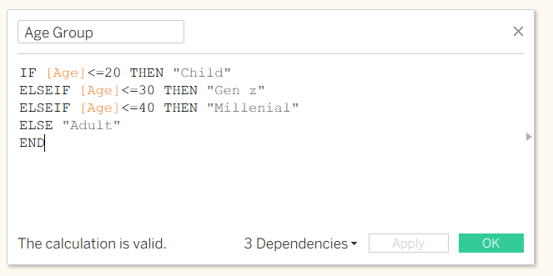

DASHBOARD DEVELOPMENT
An interactive dashboard was developed in Tableau by integrating multiple visualizations into a single, user-friendly interface. The dashboard combines key performance indicators (KPIs), heat maps, bar charts, pie charts, and donut charts to provide a comprehensive analysis of customer food ordering behaviour. It enables users to examine customer preferences, cuisine popularity, restaurant segments, meal types, revenue contribution, customer ratings, city-wise order volume, and delivery performance in one place. Interactive filters were added to allow dynamic exploration of the data, making the dashboard more flexible and easy to use. The overall layout was designed to present insights clearly, helping users quickly identify trends, compare business metrics, and support effective data-driven decision-making.

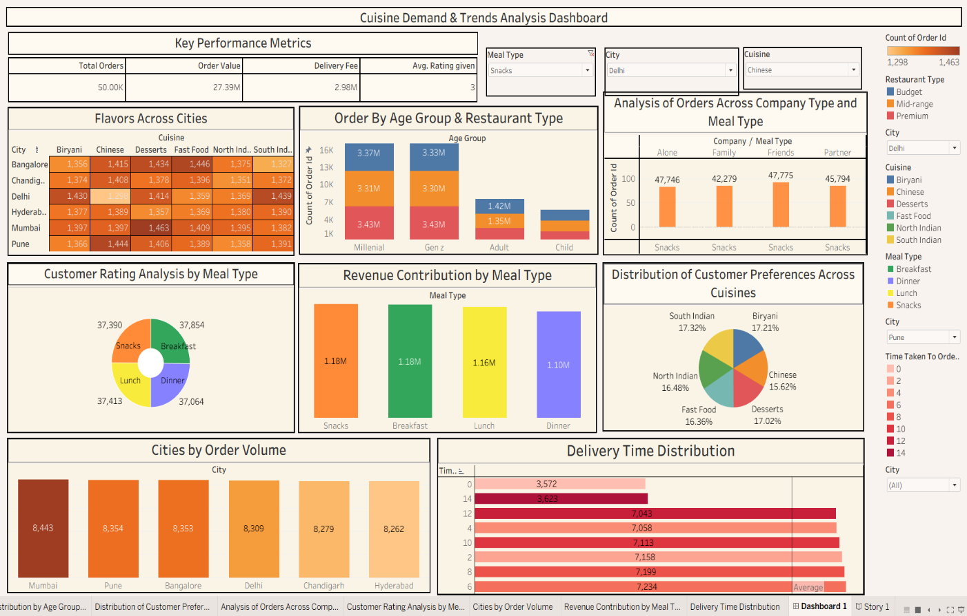

STORY DEVELOPMENT
A Tableau Story was developed to present the project findings in a logical and easy-to-understand sequence. Instead of displaying all visualizations at once, the Story feature organizes the analysis into multiple story points, allowing users to explore each business insight step by step. The story begins with the KPI Demonstration, providing an overview of the platform's overall performance through Total Orders, Total Order Value, Delivery Fee, and Average Customer Rating. It then presents customer cuisine preferences across different cities, order distribution among various age groups and restaurant segments, analysis of orders based on company type and meal type, customer rating analysis, and the distribution of delivery time across orders. This structured approach improves the presentation of insights, enhances user understanding, and supports effective business decision-making. By combining visualizations with a clear narrative flow, the Tableau Story makes the dashboard more interactive, informative, and suitable for presentations and stakeholder discussions.
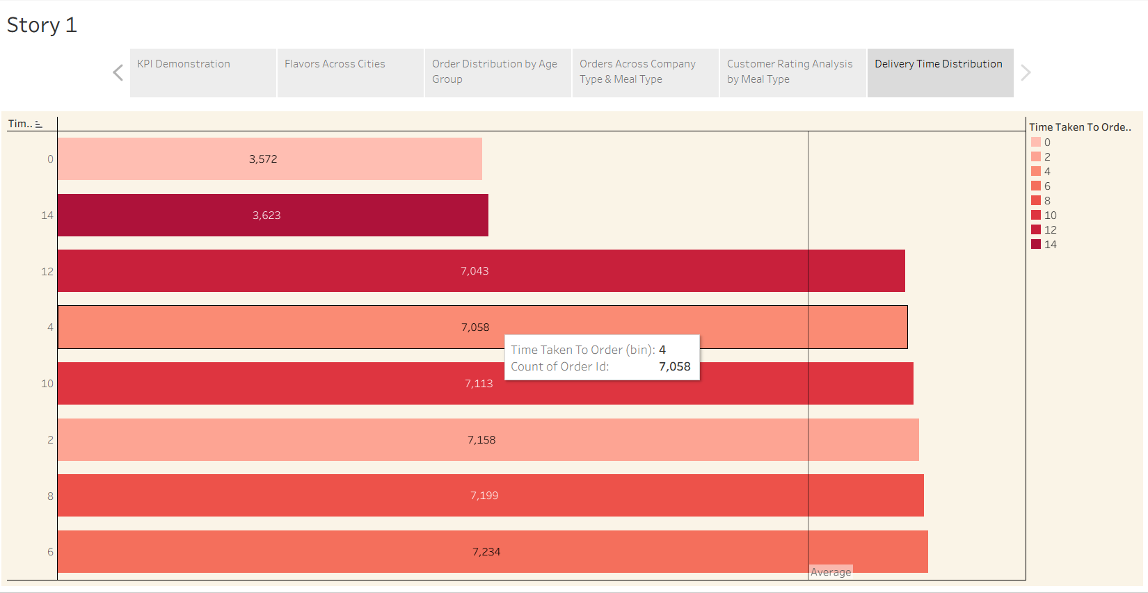

PERFORMANCE TESTING
Performance testing was carried out to evaluate the efficiency and responsiveness of the Tableau dashboard while working with a large dataset. The project successfully handled a dataset containing 50,000 records and 19 columns without any performance issues. Interactive filters, calculated fields, and multiple visualizations were tested to ensure smooth navigation and quick response during analysis. A calculated field named Age Group was created to categorize customers into meaningful segments, improving the readability of the visualizations without affecting dashboard performance. The dashboard integrates nine different visualizations, including KPI cards, heat maps, bar charts, pie charts, and donut charts, while maintaining good responsiveness and usability. Overall, the dashboard performed efficiently, providing fast interaction and a seamless user experience.

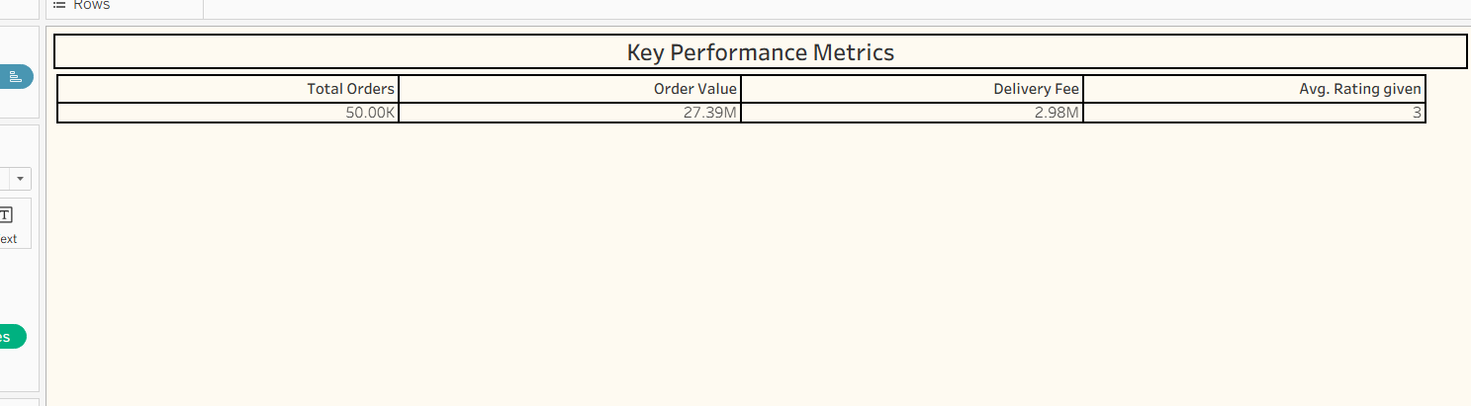

KEY FINDINGS
The analysis of the Food Ordering Behaviour dataset revealed several important business insights:
- The dashboard successfully analyzed 50,000 customer orders and provided a comprehensive overview of customer behaviour.
- Customer food preferences varied across different cities, indicating regional differences in cuisine demand.
- Millennials and Gen Z contributed a significant share of the total orders, making them the primary customer segments.
- Different company types showed varying meal preferences, highlighting differences in customer ordering patterns.
- Customer ratings remained relatively consistent across different meal types, indicating a satisfactory level of service.
- Revenue contribution varied among meal categories, helping identify the meal types that generated higher business value.
- The city-wise order analysis highlighted locations with higher customer demand and ordering activity.
- Delivery time analysis showed that most orders were delivered within the average time, reflecting efficient delivery performance.
- Interactive filters and dashboards made it easy to explore the data and gain meaningful business insights.

CONCLUSION
This project successfully analyzed customer food ordering behaviour using Tableau by transforming raw data into meaningful visualizations, interactive dashboards, and stories. The analysis provided valuable insights into customer preferences, ordering patterns, revenue contribution, customer ratings, and delivery performance. Interactive filters and calculated fields enhanced the usability of the dashboard, making it easier to explore the data and identify important business trends. Overall, the project demonstrates how Tableau can be effectively used to convert data into actionable insights, supporting informed decision-making and improving business performance in the food delivery industry.

FUTURE SCOPE
The project can be further enhanced by integrating real-time food ordering data to provide live business insights. Advanced analytics techniques such as predictive analysis and machine learning can be incorporated to forecast customer demand, recommend personalized meal options, and optimize delivery operations. Additional business metrics, customer feedback analysis, and seasonal trend analysis can also be included to improve decision-making. Furthermore, the dashboard can be deployed on Tableau Public or Tableau Server to enable secure sharing and easy access for stakeholders and business users.

